Curriculum Vitae

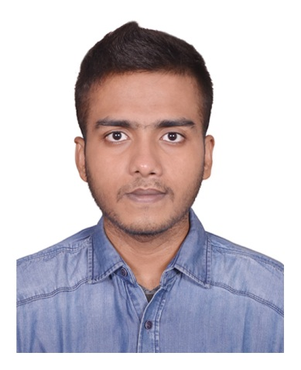

*Of*

Anik Islam

Cell: +880 1791 029358

E-mail: aanik370@gmail.com

Facebook: Rizwan Aanik

Twitter: rizwan_aanik

Objectives:

Working Experience:

Educational Qualification:

I want to involve in such a dynamic and challenging work where, I have the opportunity to emplacement my ideas to achieve my target through the organizational procedures.

1. Company Name : Jaago Foundation

Designation : Social Media Manager

Duration : From January 2013 to December 2014

1. Company Name : Ahoban Foundation

Designation : Executive & Sr. Member

Duration : From January 2014 to September 2015

1. Company Name : Independent University, Bangladesh

Designation : Teaching Assistant

Duration : From July 2016 to October 2017

**Bachelor of Business Administration (BBA)**

University : Independent University, Bangladesh

Group : School of Business

Concentration-Major: Marketing, Minor: Human Resource

Duration : 4 years (Currently Studying)

Passing Year : 2020

Result : GPA-3.35 Highest GPA-3.70, Lowest GPA-3.24

**Higher Secondary Certificate (H.S.C)**

Board : Dhaka

Institute : Dhaka City College, Dhanmondi

Group : Business Studies

Passing Year : 2015

Result : GPA-4.75 (Out of 5.00)

Language Skill**:**

Personal Details:

Skills:

Signature:

**Secondary School certificate (S.S.C)**

Board : Dhaka

Institute : Ideal School & College

Group : Business Studies

Passing Year : 2013

Result : GPA-5.00 (Out of 5.00)

Command Reading Speaking Listening

Bengali: Excellent Excellent Excellent

English: Excellent Good Good

Hindi : Avarage Excellent Excellent

Arabic : Excellent Good Good

Name : Anik Islam

Father’s Name : Md. Quddus Shaikh

Mother’s Name : Tahmim Sultana

Present Address : House-41, Road-07, Block-B,

Banasree, Rampura, Dhaka-1219

Permanent Address : House-41, Road-07, Block-B,

Banasree, Rampura, Dhaka-1219

Date of Birth : 7th July 1997

Nationality : Bangladeshi (by birth)

Religion : Muslim

Marital Status : Unmarried

Sex : Male

Blood Group : B+

Win: win goal setter

- Punctual

- Group Player

- Strategic Planner

- Friendly

- Serious At Work

- Maintaining Social Media Sections

- Colleague Managing

Capability

-Writing Articles

Travelling

Interest

Extra-Curricular Activities

References:

Declaration:

Signature

Signature:

Reading Books

Watching Movies

Driving & Maintaining Cars

Operating Fire Arms

Public Speaking

Motivating people

Attending Model United Nations Conferences

**Worked for Jaago Foundation**

• Worked for this nonprofit organization for 2 years (2011-2013) as a volunteer.

**Unpaid Internship at IUB MUN**

• Completed unemployed internship under Independent University, Bangladesh Model United **Nations (IUB MUN Forum) for 1 year (2017).**

• Participated in Dhaka University National Model UN 2017.

**Member of Independent** **Debating Club, (IUBDC) (English Wing)**

• General member of IUBDC since 2018.

• Attended Inaugural Ceremony of Ascensation 2017 (IUB Intra) & International Workshop on Debating under Model United Nations

**Member of IUB E-Business Club**

* Senior member of Independent University E-Business Club since 2017.
* A part of The Research and Development team in IUB E-Business Club.

• Organized IMA (Independent Marketer Associations) Carnival and Ascension-2017 two major Intra University events that held place at IUB campus.

* Attended LORDMUN III, as a part of the university delegation team and won the outstanding delegate award.

**Member of IUB International Affairs Club**

* Attending programs and workshops under the club
* Organized a public event.

1. **SHEIKH IQBAL KHOKON**

President, Lt. Sheikh Jamal Football Club, Dhanmondi

Cell:

1. **Ibrahim Fatemi**

Deputy Inspector General of Bangladesh Police

Cell:

I hereby declare that all the above informations are true and authentic, background checking could be done any time.

................................